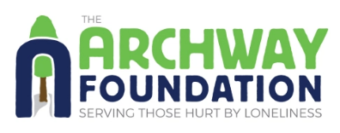
CODICIL FORM

This codicil form can be used to add The Archway Foundation as a beneficiary to your current will. You can ask a solicitor to help you complete this form and keep it safe with your will. Don’t forget that if you haven’t already made your will, you won’t need to fill out this form to name The Archway Foundation as a beneficiary.

I (full name)_______________________________________________________________________

Of (address)__________________________________________________Postcode____________

I declare this to be a
□ first □ second □ third codicil to my will, dated and made on □□ /□□ / □□□□ (day/month/year)

I give (please tick as appropriate):
□ The following proportion of the residue of my estate (please discuss details of the residue with your solicitor and ask them to specify the wording for this codicil)
□ The following specific item(s), namely_________________________________________________
□ The sum of £_____________________________________________________________________

To The Archway Foundation (Charity Registration No. 299533) New Marston Pastoral Centre, Jack Straws Lane, Oxford OX3 0DL) for its general charitable purposes. In all other respects I confirm my will and any other codicils there to.

Signed_______________________________________________ Date_________________________
Please ensure that you sign this form in the presence of two independent witnesses. The following people cannot witness your codicil: your executor, your executor’s spouse, a beneficiary of your will, a beneficiary’s spouse.
Signed by the person mentioned above, in our presence and witnessed by us in the presence of him/her and of each other.
WITNESS ONE: Name_________________________________________________________________
Address_____________________________________________________________________________
Signature___________________________________________ Date____________________________
WITNESS TWO: Name__________________________________________________________________
Address_____________________________________________________________________________
Signature___________________________________________ Date____________________________
For more information on making a will or amending your current one to include
The Archway Foundation, please contact us on: 01865 790522 / office@archwayfoundation.org.uk / www.archwayfoundation.org.uk
8 Nov 2016

