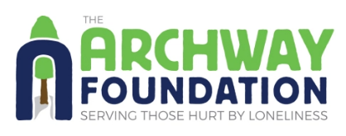
Form 1: Volunteer Application
About You:
*indicates mandatory field
Title & Full Name:* ____________________
Email:* ____________________
Date of Birth:* ____________________
Address (including postcode):*________________________________________
_________________________________________________________________
Landline: ____________________
Mobile: ____________________

Emergency Contact Name:* ____________________
Emergency Contact Number:* ____________________
Emergency Contact Relationship to You:* ____________________
Any allergies – please list below (or write ‘No’ if none)*

How did you hear about Archway?:*
- From someone who uses Archway’s services
- From an Archway Volunteer
- From an Archway Supporter
- Leaflet, poster or advert
- Event
- Search Engine
- Social Media
- Ami / Do-It / OCVA
- Archway website
- Other ____________________
(Continued on next page)

About Volunteering
If you have any experience of volunteering please describe: (not essential)

What attracts you to Archway?*

How long do you envisage being in the Oxford area?* ____________________

Volunteer roles of interest:
- Individual Support – Face-to-face
- Individual Support – Telephone Support
- Supportive Social Groups
- Volunteer Driver
- Fundraising / Event Support
Thank you for completing Form 1.
Please ensure that all fields marked* are filled in, and that Form 2 is also completed before emailing both forms to Archway.
You can find more information about volunteering with Archway, as well as online versions of these forms on our website.
If you need any help completing this form or have any queries, please email: office@archwayfoundation.org.uk or call 01865 790552.

