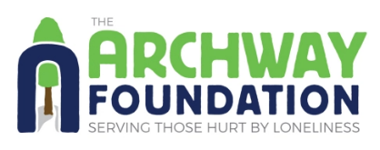
Form 2: Equalities Information
This information is confidential and is used for the purpose of monitoring, which we need to collect for our funders. It is separated from the application form before applications are considered.
Please tick the relevant category in which you would place yourself.
In each category there is an option to select 'Do not wish to say'.

Ethnic Background:

- White - English/Scottish/Welsh/Northern Irish/UK
- White - Irish
- White - Any other background
- White – Gypsy or Traveller
- Mixed / Multiple Ethnic Background
- Asian / Asian UK - Indian
- Asian / Asian UK - Pakistani
- Asian / Asian UK - Bangladeshi
- Asian / Asian UK - Chinese
- Any other Asian background
- Black / Black UK - African
- Black / Black UK - Caribbean
- Black / Black UK – Any other Black/African/Caribbean
- Arab
- Other
- Do not wish to say

Gender:

- Non-binary
- Other
- Do not wish to say

Disability

- Disabled
- Not disabled
- Do not wish to say

(Continued on next page)
Religion or belief:
- No religion
- Christian
- Buddhist
- Hindu
- Jewish
- Muslim
- Sikh
- Other religion
- Do not wish to say

Sexual orientation
- Heterosexual/Straight
- Lesbian/Gay woman
- Gay man
- Bisexual
- Other
- Do not wish to say

Please ensure that you complete the section below.
To be able to process your application it is important that we seek and secure your consent to process and secure your information on our secure database. A copy of our data protection policy can be found here to you should you wish to see it.

Name:* _____________________________
Date:* ____________________________
I consent for the information contained in this form being processed and stored by The Archway Foundation* (Please sign or write your name below to confirm):
______________________________________
Thank you for completing Form 2.
Please ensure that all fields marked* are filled in, and that Form 1 is also completed before emailing both forms to Archway.
You can find more information about volunteering with Archway, as well as online versions of these forms on our website.
If you need any help completing this form or have any queries, please email: office@archwayfoundation.org.uk or call 01865 790552.

